
AI-ENHANCED VOICE RECOGNITION SYSTEM FOR ARDUINO LED CONTROL
A CAPSTONE PROJECT REPORT
A Capstone Project Report submitted in partial fulfilment of the requirements
for the Course of
MLA0101 – Artificial Intelligence and Expert Systems
0to the award of the degree of
BACHELOR OF TECHNOLOGY
IN
ARTIFICIAL INTELLIGENCE AND MACHINE LEARNING
Submitted by
Mokshitha Kilari (192525413)
Chandana K (192525363)
Juhi Surin (192525148)
Under the Supervision of
Dr. P. Subramanian
Dept. of CSE
SIMATS ENGINEERING
Saveetha Institute of Medical and Technical Sciences
Chennai-602105
SEPTEMBER 2026

SIMATS ENGINEERING
Saveetha Institute of Medical and Technical Sciences
Chennai-602105
BONAFIDE CERTIFICATE
This is to certify that the Capstone Project entitled “AI-Enhanced Voice Recognition System for Arduino LED Control” has been carried out by Mokshitha Kilari (192525413), Chandana K (192525363), and Juhi Surin (192525148) under the supervision of Dr. P. Subramanian and is submitted in partial fulfilment of the requirements for the current semester of the B.Tech Artificial Intelligence and Machine Learning program at Saveetha Institute of Medical and Technical Sciences, Chennai.

COURSE COORDINATOR | COURSE FACULTY
Title / Name,  Designation  Branch / Department Name  SIMATS Engineering, SIMATS, Chennai – 602105. | Title / Name,  Designation  Branch / Department Name  SIMATS Engineering, SIMATS, Chennai – 602105.

SIMATS ENGINEERING
Saveetha Institute of Medical and Technical Sciences
Chennai-602105
DECLARATION
We, Mokshitha Kilari (192525413), Chandana K (192525363), and Juhi Surin (192525148) of the Artificial Intelligence and Machine Learning program, SIMATS Engineering, Saveetha Institute of Medical and Technical Sciences, Chennai, hereby declare that the Capstone Project Work entitled “AI-Enhanced Voice Recognition System for Arduino LED Control” is the result of our own bonafide efforts. To the best of our knowledge, the work presented herein is original, accurate, and has been carried out in accordance with the principles of engineering ethics and academic integrity. All sources, references, data, and other materials used in the project have been appropriately acknowledged.
We further declare that the data, results, analysis, and findings presented in this report have not been fabricated, falsified, or manipulated. Any external tools, software, datasets, computational resources, or AI-assisted tools used during the project have been appropriately disclosed. We confirm that all applicable ethical, academic, institutional, and professional requirements have been duly followed throughout the planning, execution, analysis, and documentation of the project.

Place: Chennai
Date: September 2026

Signature of the Students with Names

SIMATS ENGINEERING
Saveetha Institute of Medical and Technical Sciences
Chennai-602105
Individual Contribution Statement
(Mandatory for all team projects)
Student Name /  Register No. | Specific  Responsibilities | Design &  Development  Contribution | Testing &  Analysis  Contribution | Report  Contribution | Approx.  Contribution  (%)
Mokshitha Kilari /  192525413 | Module 1: Voice recognition and AI processing; command definition and documentation. | Designed the Module 1 voice-command workflow and recognition logic; mapped spoken commands to digital commands. | Verified command recognition behaviour in quiet and moderate-noise conditions and reviewed response observations. | Chapters 1–5 sections related to Module 1, architecture, testing, analysis and reflection. | 40%
Chandana K /  192525363 | Module 2: Wireless command transmission using Bluetooth HC-05. | Worked on Bluetooth-based command transfer and interface between the recognition layer and Arduino. | Checked command transfer and communication flow. | Sections related to wireless transmission and supporting documentation. | 30%
Juhi Surin /  192525148 | Module 3: Arduino LED control and hardware integration. | Worked on Arduino command processing, GPIO activation and LED output integration. | Checked LED ON/OFF response and hardware operation. | Sections related to Arduino control, results and project support. | 30%

SIMATS ENGINEERING
Saveetha Institute of Medical and Technical Sciences
Chennai-602105
ABSTRACT
The project presents an AI-Enhanced Voice Recognition System for Arduino LED Control that enables hands-free operation of red, green and blue LEDs using spoken commands. Traditional LED control generally depends on manual switches, which can be inconvenient and does not provide intelligent voice interaction. The proposed system addresses this limitation by combining voice input, speech recognition, Bluetooth communication and Arduino-based hardware control. The system accepts a voice command through a microphone or smartphone, processes the speech using an AI/speech-recognition layer, converts the recognized intent into a predefined digital command, and prepares it for wireless transmission. The complete project is organized into three modules: Module 1 performs voice recognition and AI processing, Module 2 transfers the recognized command wirelessly through Bluetooth HC-05, and Module 3 processes the command on Arduino Uno R3 and activates the required GPIO output for the corresponding LED. The Module 1 contribution focuses on converting human speech into recognizable commands such as LED_ON, LED_OFF, RED_ON, GREEN_ON and BLUE_ON. Testing observations from the project indicate successful LED control, accurate recognition of basic commands and minimal response delay in a quiet environment. Moderate background noise slightly reduced recognition accuracy. The resulting system demonstrates that AI-assisted voice recognition can improve the convenience and user-friendliness of a low-cost embedded automation system. The prototype is suitable as a foundation for smart-home automation and can be extended to other connected devices.
Keywords: Voice Recognition, Artificial Intelligence, Arduino Uno, Bluetooth HC-05, LED Control, Smart Home Automation

SIMATS ENGINEERING
Saveetha Institute of Medical and Technical Sciences
Chennai-602105
TABLE OF CONTENTS
Sl.  No | Title | Page  No
i | CERTIFICATE FROM THE SUPERVISOR | ii
ii | DECLARATION BY THE CANDIDATE | iii
iii | INDIVIDUAL CONTRIBUTION STATEMENT | iv
iv | ABSTRACT | v
v | LIST OF FIGURES | vi
vi | LIST OF TABLES | vii
vii | LIST OF ABBREVIATIONS | viii
1 | CHAPTER 1: Introduction and Engineering Problem | 1
2 | CHAPTER 2: Literature Review and Existing Solutions | 3
3 | CHAPTER 3: Engineering Design & Trade-offs, Sustainability, Ethics, Safety, Risk & Security | 6
4 | CHAPTER 4: Implementation, Testing & Results, Project Management | 11
5 | CHAPTER 5: Conclusion, Future Work and Reflection | 15
 | References | 17
 | Appendices | 18

SIMATS ENGINEERING
Saveetha Institute of Medical and Technical Sciences
Chennai-602105
LIST OF FIGURES
Figure No. | Figure Name | Page No.
Figure 3.1 | System Architecture | 7
Figure 4.1 | Prototype / Output Evidence | 12

SIMATS ENGINEERING
Saveetha Institute of Medical and Technical Sciences
Chennai-602105
LIST OF TABLES
Table No. | Table Name | Page No.
Table 1.1 | Project Objectives | 2
Table 2.1 | Review of Existing Work | 4
Table 2.2 | Comparative Analysis | 5
Table 3.1 | Stakeholder / User Requirements | 6
Table 3.2 | Functional & Non-Functional Requirements | 6
Table 3.3 | Design Specifications | 7
Table 3.4 | Alternative Solutions & Evaluation | 8
Table 3.5 | Trade-off Analysis | 9
Table 3.6 | Sustainability, Ethics, Safety & Security | 10
Table 3.7 | Risk Register | 10
Table 4.1 | Tools / Software / Equipment | 11
Table 4.2 | Test Plan & Verification | 12
Table 4.3 | Results Summary | 13
Table 4.4 | Achievement of Objectives | 13
Table 4.5 | Project Roles & Budget | 14

SIMATS ENGINEERING
Saveetha Institute of Medical and Technical Sciences
Chennai-602105
LIST OF ABBREVIATIONS / SYMBOLS
Symbol | Description | Unit
AI | Artificial Intelligence | —
LED | Light Emitting Diode | —
GPIO | General Purpose Input/Output | —
UART | Universal Asynchronous Receiver/Transmitter | —
HC-05 | Bluetooth serial communication module | —
PC | Personal Computer | —
RGB | Red, Green and Blue | —

SIMATS ENGINEERING
Saveetha Institute of Medical and Technical Sciences
Chennai-602105
CHAPTER 1
INTRODUCTION AND ENGINEERING PROBLEM

1.1 Background
Voice-controlled technology is increasingly useful in smart-home and automation applications because it allows users to interact with devices without relying entirely on physical switches. The project combines an AI/speech-recognition layer with Arduino Uno R3, Bluetooth communication and RGB LED outputs. A user provides a spoken command through a microphone or smartphone; the voice is captured and processed, the intended command is identified, and the recognized command is passed to the hardware control layer.
The system is divided into three functional modules. Module 1 performs voice recognition and AI processing, Module 2 provides wireless command transmission through Bluetooth HC-05, and Module 3 performs Arduino-based LED control. The first module is the primary individual contribution documented in this report.

1.2 Need for the Project
• Traditional LED systems require manual switches for operation.
• Manual control can be inconvenient for users who need or prefer hands-free interaction.
• Conventional systems do not provide intelligent voice interaction.
• A simple and affordable voice-controlled automation system can demonstrate practical integration of AI with embedded hardware.
• The engineering significance lies in connecting a human-language input layer with a low-cost physical control system.

1.3 Problem Statement
Design and implement a low-cost voice-controlled LED automation system in which spoken commands are recognized using an AI/speech-processing layer, converted into predefined digital commands, transmitted wirelessly, and executed by an Arduino controller to operate red, green and blue LEDs in real time. The system must provide reliable basic command recognition while operating under realistic constraints such as background noise, limited hardware resources and wireless communication dependence.

1.4 Project Aim
To develop an AI-enhanced voice recognition and embedded control system that enables hands-free, real-time operation of LEDs through spoken commands.

1.5 Project Objectives
1. To design a voice-controlled LED system using AI/speech recognition.
2. To recognize predefined spoken commands accurately.
3. To transmit recognized commands wirelessly to Arduino.
4. To control LEDs in real time based on the received command.
5. To provide a hands-free and user-friendly interaction method.
6. To create a low-cost solution that can be extended to other smart devices.
Objective | Measurable / Observable Evidence
Voice recognition | Predefined commands are recognized and mapped to digital commands.
Wireless transmission | Recognized command is transferred through the Bluetooth communication path.
LED control | Arduino activates the corresponding LED output.
Response | Command-to-output operation occurs with minimal observed delay.

1.6 Scope
Included in the project are voice input, speech/AI command recognition, predefined command mapping, Bluetooth-based command transmission, Arduino Uno R3 processing, and red/green/blue LED control. The scope is a prototype-level automation system rather than a complete commercial smart-home platform.
The system assumes that the user speaks one of the supported commands and that the microphone/smartphone, Bluetooth link and Arduino hardware are available. The supplied project material does not specify a numerical recognition-accuracy target, a particular speech-recognition model, or a detailed environmental noise threshold; therefore, these are treated as project limitations rather than invented specifications.

1.7 Expected Engineering Outcome
The intended outcome is a working prototype and command-processing workflow that converts voice input into a digital control command and ultimately produces the corresponding LED output. The engineering contribution documented individually is the Module 1 voice-recognition and AI-processing stage, including the command vocabulary and its mapping to digital control identifiers.

SIMATS ENGINEERING
Saveetha Institute of Medical and Technical Sciences
Chennai-602105
CHAPTER 2
LITERATURE REVIEW AND EXISTING SOLUTIONS

2.1 Review Method
Relevant work was reviewed from the references supplied with the project presentation. The review focused on embedded voice recognition, TinyML-based voice recognition, offline home automation, AI-assisted voice-controlled embedded systems, and Arduino-based LED control. The purpose was to understand common architectures and identify how the proposed three-module arrangement addresses the project requirement.

2.2 Review of Existing Work
Existing Work / Technology | Key Idea | Relevance to Proposed Work
TinyML voice recognition on Arduino-class hardware | Voice recognition can be brought closer to embedded hardware using compact machine-learning approaches. | Supports the feasibility of combining voice recognition with low-cost embedded control.
Offline AI home automation with Arduino and local voice recognition | Local voice recognition can support home-automation control without depending entirely on cloud processing. | Motivates practical, low-cost voice-driven device control.
AI-assisted voice-controlled prosthetic systems | Speech/AI processing can be used as an interaction layer for physical actuation. | Demonstrates the broader applicability of voice-to-action pipelines.
Arduino-based LED control through communication networks | Arduino can execute LED control commands received through a communication interface. | Supports the hardware execution stage of the proposed system.

2.3 Comparative Analysis
Existing Approach | Advantages | Limitations | Relevance to Proposed Work
Manual LED switching | Simple, inexpensive, direct. | Requires physical interaction; no intelligent voice interface. | Baseline limitation addressed by the project.
Web/IoT LED control | Remote and network-enabled. | Requires network/application interface; more infrastructure. | Provides an alternative to voice-based interaction.
Embedded/TinyML voice recognition | Closer to hardware; can reduce dependence on external services. | Resource and model constraints. | Relevant to future enhancement of Module 1.
Proposed voice + Bluetooth + Arduino | Hands-free, low-cost, modular and easy to demonstrate. | Recognition accuracy is affected by background noise; Bluetooth adds a communication dependency. | Directly satisfies the project requirement.

2.4 Research / Engineering Gap
The reviewed approaches show that voice recognition, embedded control and wireless communication can be combined, but the supplied project is specifically organized as a simple three-module pipeline intended for low-cost LED automation. The engineering gap addressed at the prototype level is the integration of a human voice command into a simple embedded output system without requiring manual LED switching.

2.5 Proposed Contribution
The proposed contribution is a modular voice-to-LED control pipeline. Module 1 converts human speech into predefined digital commands; Module 2 transfers those commands wirelessly; and Module 3 executes them on Arduino. The individual contribution is centered on Module 1, making the command-recognition stage clear, testable and compatible with the downstream Bluetooth and Arduino interfaces.

SIMATS ENGINEERING
Saveetha Institute of Medical and Technical Sciences
Chennai-602105
CHAPTER 3
ENGINEERING DESIGN & TRADE-OFFS, SUSTAINABILITY, ETHICS, SAFETY, RISK & SECURITY

3.1 Requirements
The system requirements were derived from the project objective of hands-free LED control and from the architecture presented in the project material.
Stakeholder | Requirement
End User | Provide simple voice commands for LED control.
Project Team | Use a low-cost and understandable hardware/software architecture.
Evaluator | Demonstrate identifiable modules, testing evidence and a working output.

Requirement | Type  (Functional/Non-Functional) | Measurable Target
Recognize predefined voice commands | Functional | Commands such as Turn ON LED, Turn OFF LED, Red LED ON, Green LED ON and Blue LED ON are mapped to digital commands.
Generate a digital command | Functional | Recognized command is prepared for transmission.
Hands-free operation | Non-Functional | No physical switch is required for the voice-command path.
Low response delay | Non-Functional | Minimal observed delay between valid command and LED action.
Noise tolerance | Non-Functional | Basic recognition remains usable in quiet conditions; moderate noise may reduce accuracy.

3.2 Constraints & Applicable Standards
Only constraints that are supported by the project material are included. The supplied presentation does not identify a specific formal hardware standard or regulatory code, so no unsupported standard is claimed.
Standard / Code | Requirement | How Applied in This Project
Project-specific academic format | Report must document individual contribution and engineering evidence. | Individual Module 1 work is separately described in the contribution statement and Chapter 4.
Electrical safety practice for low-voltage prototyping | Avoid unsafe wiring and short circuits during breadboard operation. | Low-voltage Arduino/LED prototype uses resistors with LEDs and a regulated 5 V supply.

3.3 Design Specifications
Parameter | Target/Requirement | Unit | Priority
Voice command set | Predefined commands mapped to LED actions | commands | High
Command output | LED_ON / LED_OFF / RED_ON / GREEN_ON / BLUE_ON | text | High
Controller | Arduino Uno R3 | device | High
Wireless link | Bluetooth HC-05 | module | High
LED outputs | Red, Green and Blue LEDs | 3 outputs | High
LED series resistor | 220 | ohm | High
Power source | 5 V USB / adapter with regulated supply | V | High

3.4 Alternative Solutions & Evaluation
Alternative 1: Manual switch-based control. This is the simplest implementation but does not satisfy the intelligent voice interaction requirement.
Alternative 2: Web/IoT-based LED control. This enables remote control but introduces network and application dependencies that are unnecessary for the prototype objective.
Alternative 3: Voice recognition + Bluetooth + Arduino. This provides the required voice interaction while retaining a simple, modular and low-cost embedded architecture.
Criterion | Weight | Alternative 1 | Alternative 2 | Alternative 3
Performance | 30% | Medium | High | High
Cost | 20% | High | Medium | High
Safety | 15% | High | Medium | High
Sustainability | 15% | High | Medium | High
Reliability | 20% | High | Medium | Medium–High

3.5 Selected Design & Detailed Design
The selected design is the three-stage architecture because it separates speech interpretation, wireless communication and physical actuation. This modularity makes the system easier to understand, test and extend. For the individual Module 1 contribution, the key design decision is to map recognizable voice intents to a small, predefined command vocabulary that can be transmitted as digital text.
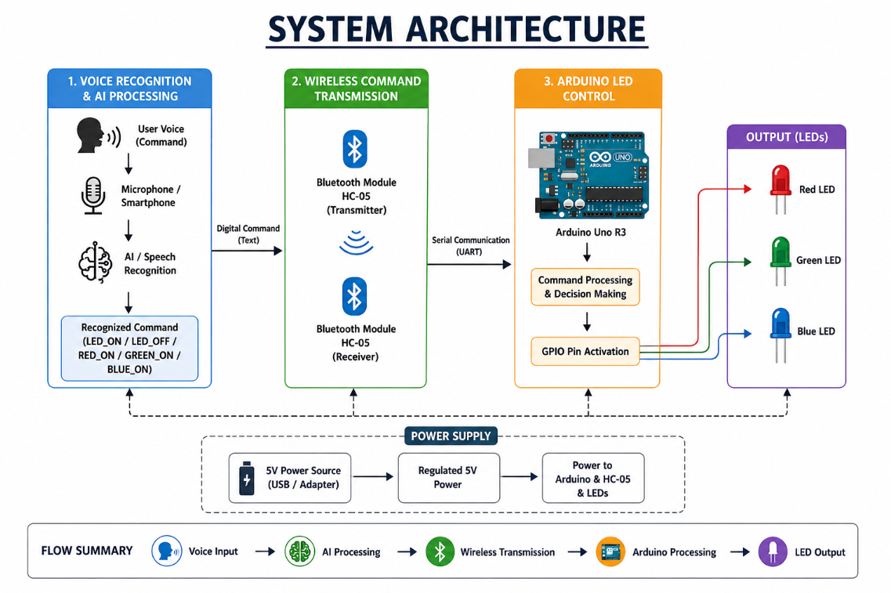
Figure 3.1: System Architecture
Systems approach: the voice input enters Module 1, where speech recognition identifies the intended command. The resulting digital command is passed to Module 2 for Bluetooth transmission. Module 3 receives the command, compares it with predefined actions and activates the required GPIO output, producing the corresponding LED state.

3.6 Trade-off Analysis
Design Decision | Alternative Considered | Benefit | Disadvantage | Final Decision & Justification
Predefined command vocabulary | Free-form natural language | Simple mapping and predictable hardware control. | Less flexible than unrestricted language. | Selected because the prototype requires reliable control of a small LED command set.
Bluetooth HC-05 | Network/IoT communication | Simple serial wireless link and low infrastructure requirement. | Limited to the Bluetooth communication path. | Selected for a compact, demonstrable prototype.
Arduino Uno R3 | More powerful controller | Accessible, simple and suitable for LED control. | Limited processing resources. | Selected because downstream control is lightweight.

3.7 Sustainability, Ethics, Safety, Risk & Security
Domain | Consideration | Evidence Evaluated | Impact on Final Decision
Sustainability | Low-cost reusable prototype hardware. | Arduino, breadboard, resistors and LEDs can be reused. | Favours a modular low-cost design.
Ethics | Transparent handling of project data and AI assistance. | Commands are predefined; no personal data set is described in the supplied material. | Keeps the prototype focused on device control.
Health & Safety | Avoid unsafe electrical connections. | Low-voltage 5 V supply and current-limiting resistors. | Supports safe prototype operation.
Security | Wireless command path should accept only intended control commands. | Predefined command vocabulary and Bluetooth communication. | Reduces unintended command interpretation at the control layer.

Risk | Likelihood | Severity | Risk Level | Mitigation | Residual Risk
Background noise affects recognition | Medium | Medium | Medium | Use clear speech and test in quieter conditions. | Low–Medium
Bluetooth communication interruption | Low–Medium | Medium | Medium | Check pairing and communication path before testing. | Low
Incorrect command interpretation | Low–Medium | Medium | Medium | Use a limited predefined command vocabulary. | Low
LED wiring error | Low | Medium | Low–Medium | Use 220 ohm resistors and verify connections. | Low

SIMATS ENGINEERING
Saveetha Institute of Medical and Technical Sciences
Chennai-602105
CHAPTER 4
IMPLEMENTATION, TESTING & RESULTS, PROJECT MANAGEMENT

4.1 Development Approach & Resources
The project was developed as a modular prototype. The voice-recognition stage was defined first so that each spoken input could be represented by a consistent digital command. The wireless stage then provides a communication path between the recognition layer and Arduino, while the final stage maps commands to LED GPIO outputs. Development and testing were performed around the predefined command set supplied in the project presentation.
Resource | Use in Project
Microphone / Smartphone | Captures the user's voice command.
AI / Speech Recognition | Processes speech and identifies the intended command.
Arduino Uno R3 | Receives commands and controls LED GPIO outputs.
Bluetooth HC-05 | Provides wireless command transmission.
RGB LEDs | Provide visible output for recognized actions.
220 ohm resistors | Limit LED current.
Breadboard and jumper wires | Prototype interconnections.
5 V USB / adapter | Provides low-voltage power.

4.2 Hardware / Software / Fabrication Implementation & Modern Tools Used

Software / AI Processing
Module 1 accepts a voice command, processes the speech through a recognition layer, identifies the intended action and converts it into a predefined digital command. Example: “Turn ON LED” is represented as LED_ON. This output format allows the downstream Bluetooth and Arduino modules to remain simple.

Hardware Implementation
The physical system uses Arduino Uno R3, three LEDs representing red, green and blue output, three 220 ohm resistors, a breadboard, jumper wires and Bluetooth HC-05 modules. The architecture identifies the Bluetooth link as the bridge between the recognized command and Arduino serial communication.

Tool / Software / Equipment | Purpose | Stage Used
Speech recognition / AI layer | Convert voice into recognized command | Module 1
Smartphone / Microphone | Capture voice input | Module 1
Bluetooth HC-05 | Transmit command wirelessly | Module 2
Arduino Uno R3 | Process command and control GPIO | Module 3
Red/Green/Blue LEDs | Visualize command result | Module 3
Breadboard + jumper wires | Prototype circuit | Hardware integration

4.3 Test Plan & Verification
Testing was planned around the command vocabulary and the visible hardware response. The supplied project results describe successful control, accurate basic recognition, minimal delay in quiet conditions and reduced accuracy under moderate background noise. Since the project presentation does not provide numerical latency or accuracy measurements, the report records the evidence qualitatively rather than inventing values.
Requirement | Test Method | Acceptance Criterion
Turn ON LED | Speak the command and observe output. | LED turns ON.
Turn OFF LED | Speak the command and observe output. | LED turns OFF.
Red LED ON | Speak command and observe red LED. | Red LED turns ON.
Green LED ON | Speak command and observe green LED. | Green LED turns ON.
Blue LED ON | Speak command and observe blue LED. | Blue LED turns ON.
Noise condition | Repeat commands in a moderately noisy environment. | Command remains usable, with reduced accuracy documented if observed.

Specification | Required Value | Achieved Value | Status (Pass/Fail)
Basic voice command recognition | Predefined commands | Commands detected correctly in project testing | Pass
LED ON/OFF operation | Corresponding LED state | Arduino-connected LED operated through voice commands | Pass
Response | Minimal delay | Minimal observed delay | Pass
Noise robustness | Reliable recognition | Moderate noise slightly reduced accuracy | Partial

4.4 Results
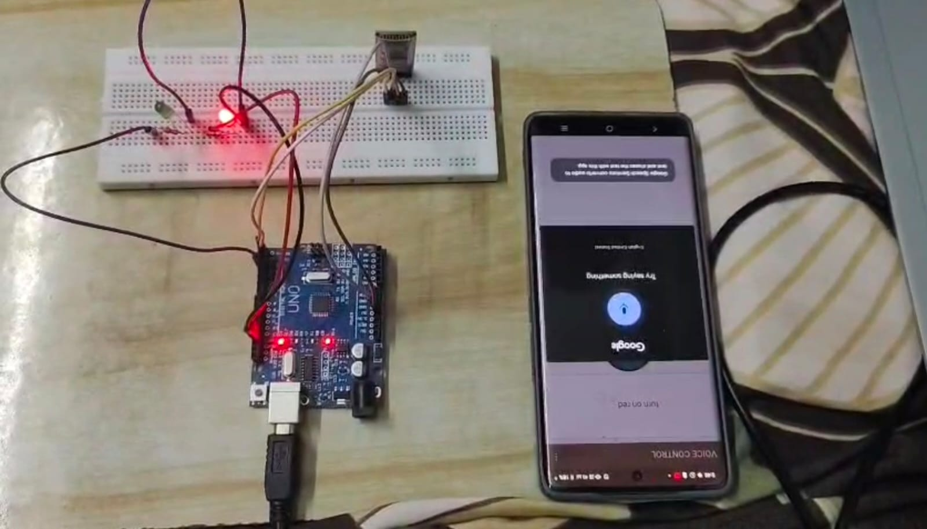
Figure 4.1: Prototype / Output Evidence
Observation | Result
Successful Control | Arduino-connected LED operated through voice commands.
Accurate Recognition | Commands such as “turn on” and “turn off” detected correctly.
Fast Response | Minimal delay in execution.
Quiet Environment | High reliability and quick response.
Background Noise | Moderate noise slightly reduced accuracy.
Overall Outcome | AI integration improved efficiency and user-friendliness of voice-based hardware control.

4.5 Data Analysis & Engineering Judgment
The available project evidence indicates that the system performs reliably for the basic command set under quiet conditions. The main observed deviation is reduced recognition accuracy in moderate background noise. From an engineering perspective, this suggests that the recognition stage is the most environment-sensitive part of the pipeline. A practical improvement would be to use stronger noise handling, a more robust speech-recognition model or a compact on-device model, but such an implementation is outside the evidence supplied for the present prototype.

4.6 Comparison with Existing Solutions & Achievement of Objectives
Objective | Evidence | Achievement (Fully/Partially/Not Achieved)
Design a voice-controlled LED system using AI | Three-module voice-to-LED architecture. | Fully
Recognize spoken commands accurately | Basic commands detected correctly. | Fully
Transmit recognized commands wirelessly | Bluetooth HC-05 communication path. | Fully
Control LEDs in real time | Arduino-connected LED operated through voice commands. | Fully
Provide hands-free operation | Voice command replaces manual switching. | Fully
Create an extensible low-cost solution | Arduino + Bluetooth + LEDs form a modular prototype. | Fully

4.7 Strengths & Limitations
Strengths:
• Simple modular architecture with clearly separated functions.
• Hands-free operation through voice commands.
• Low-cost hardware using Arduino, LEDs, resistors and Bluetooth.
• Fast visible feedback through LED outputs.
• Module 1 command mapping provides a clear interface to the downstream modules.
Limitations:
• Recognition accuracy decreases in moderate background noise.
• The supplied project material does not specify numerical accuracy or latency measurements.
• The command vocabulary is predefined and therefore less flexible than unrestricted natural-language interaction.
• Bluetooth communication introduces a wireless dependency.

4.8 Project Planning, Roles & Budget
Milestone | Planned Activity | Outcome
1 | Define problem, objectives and command set | Project requirements established.
2 | Develop Module 1 voice-recognition workflow | Voice-to-command mapping established.
3 | Integrate Bluetooth communication | Recognized command prepared for wireless transfer.
4 | Integrate Arduino LED control | Hardware output connected.
5 | Test commands and noise conditions | Successful control and noise limitation observed.
6 | Document individual contributions and results | Capstone report prepared.

Student | Assigned Responsibility | Actual Contribution
Mokshitha Kilari | Module 1 – Voice Recognition & AI Processing | Voice-command workflow, command mapping, Module 1 testing/analysis and report sections.
Chandana K | Module 2 – Wireless Command Transmission | Bluetooth HC-05 communication and related documentation.
Juhi Surin | Module 3 – Arduino LED Control | Arduino command processing, GPIO control, LED integration and related documentation.

Item | Estimated Cost | Actual Cost
Arduino Uno R3 | Project-supplied / not specified | Not specified
LEDs and 220 ohm resistors | Project-supplied / not specified | Not specified
Breadboard and jumper wires | Project-supplied / not specified | Not specified
Bluetooth HC-05 | Project-supplied / not specified | Not specified

SIMATS ENGINEERING
Saveetha Institute of Medical and Technical Sciences
Chennai-602105
CHAPTER 5
CONCLUSION, FUTURE WORK AND REFLECTION

5.1 Conclusion
The AI-Enhanced Voice Recognition System for Arduino LED Control demonstrates a practical voice-to-hardware control workflow. The system combines voice recognition, wireless communication and Arduino-based LED control to provide hands-free operation. The project achieved successful basic voice-command recognition and visible LED control with minimal observed delay in quiet conditions. The main limitation identified was reduced recognition accuracy under moderate background noise. Overall, the prototype provides an affordable and practical foundation for smart-home automation and similar assistive control applications.

5.2 Future Work
• Improve Module 1 recognition robustness using noise filtering and a more robust speech-recognition model.
• Explore on-device or TinyML-based recognition for reduced dependence on external processing.
• Expand the command vocabulary while retaining reliable command-to-action mapping.
• Add more smart-home devices such as fans, relays or other low-power actuators.
• Introduce authentication or command validation for stronger wireless security.
• Collect numerical accuracy and latency measurements over a larger test set.

5.3 Professional Learning & Individual Reflection
New Knowledge Acquired:
• Understanding of the voice-input to digital-command pipeline.
• Practical command mapping between speech recognition and embedded control.
• Understanding of how AI-based recognition can interface with a hardware controller.
• Awareness of environmental noise as a real engineering constraint.
Engineering & Professional Skills Developed:
• System decomposition into independent functional modules.
• Requirement identification and test planning.
• Technical documentation and evidence-based engineering judgment.
• Communication of an AI concept as an implementable embedded workflow.
Individual Reflection – Mokshitha Kilari:
The most difficult engineering issue in Module 1 was ensuring that a spoken instruction could be converted into a predictable command that the hardware layer could understand. I addressed this by using a small predefined command vocabulary and mapping each recognized intent to a digital identifier such as LED_ON. A key engineering decision was to keep the recognition output independent of the Arduino implementation, which made the interface between modules simple. I also learned that background noise directly affects recognition reliability and that practical AI systems must be evaluated under realistic conditions. If the project were repeated, I would improve the recognition stage with stronger noise handling and collect quantitative accuracy and latency data.

SIMATS ENGINEERING
Saveetha Institute of Medical and Technical Sciences
Chennai-602105
REFERENCES
[1] P. Patel, N. Gupta, and S. Gajjar, “Real time voice recognition system using tiny ml on arduino nano 33 ble,” 2025 IEEE International Symposium on Smart Electronic Systems (iSES). IEEE, 2025.
[2] T. U. Rahaman, K. Dutta, and S. Kar, “AI-Powered Offline Home Automation Framework Using Arduino and Local Voice Recognition,” in 2026 International Conference on Emerging Research in Smart Electronics and Machine Informatics (ECMI), pp. 1–10, Apr. 2026.
[3] R. S. Ramya, “AI-Assisted Voice Controlled Prosthetic Arm using High-Performance Embedded Microcontroller,” International Journal of Engineering & Extended Technologies Research (IJEETR), vol. 8, no. 2, pp. 3587–3593, 2026.
[4] M. Hariri, “LED Control System Using Arduino Wemos D1 R1 Based on Web Server Communication Via Internet of Things (IoT),” Formosa Journal of Science and Technology, 2025.
[5] P. Patel, N. Gupta, and S. Gajjar, “Real time voice recognition system using tiny ml on arduino nano 33 ble,” in 2024 IEEE International Symposium on Smart Electronic Systems (iSES), pp. 385–388, Dec. 2024.
Note: The references above are reproduced from the project presentation supplied for this report. No additional external sources have been introduced.

SIMATS ENGINEERING
Saveetha Institute of Medical and Technical Sciences
Chennai-602105
APPENDICES

Appendix A – Detailed Calculations
No extended engineering calculations were supplied in the project presentation. The main hardware requirement explicitly identified is the use of 220 ohm resistors with the LEDs. Detailed circuit calculations may be added if measured electrical values are available.

Appendix B – Engineering Drawings / Schematics
The system architecture shown as Figure 3.1 is the principal engineering architecture supplied with the project.

Appendix C – Source Code / Code Repository Information
The supplied presentation does not contain the complete source code or a repository URL. Complete source code should be maintained separately in the approved repository, in accordance with the faculty format.

Appendix D – Datasheets
Relevant component datasheets may be attached separately if required by the department.

Appendix E – Experimental / Raw Data
The supplied project material reports qualitative observations: successful control, accurate basic recognition, minimal delay, high reliability in quiet conditions, and reduced accuracy under moderate background noise. Numerical raw measurements were not supplied.

Appendix F – Ethics / Institutional Approval
No separate institutional approval document was supplied for this prototype.

Appendix G – Project Meeting / Progress Records
To be maintained separately if required by the course faculty.

Appendix H – User/Industry Feedback
No external user or industry feedback was supplied in the project presentation.

Appendix I – Publications / Patents / Competitions / Product Outcomes
No publication, patent, competition or product outcome was supplied for this project.

Appendix J – Individual Contribution Evidence
The individual contribution is centered on Module 1: Voice Recognition & AI Processing. The contribution includes defining the voice-command workflow, mapping recognized speech to digital commands, supporting testing/analysis, and documenting the module in the capstone report.

SIMATS ENGINEERING
Saveetha Institute of Medical and Technical Sciences
Chennai-602105
CAPSTONE PROJECT OUTCOME MAPPING SHEET
To be completed by the department/faculty assessor.
Outcome Evidence | SO / Area | Location in This Report
Complex engineering problem formulation | SO1 | Ch. 1, Ch. 2
Engineering design under constraints | SO2 | Ch. 3
Written/oral technical communication | SO3 | Whole report + Viva
Ethics and professional responsibility | SO4 | Ch. 3 (3.7)
Teamwork and leadership | SO5 | Ch. 4 (4.8)
Experimentation, analysis, engineering judgment | SO6 | Ch. 4 (4.3–4.6)
Independent acquisition of new knowledge | SO7 | Ch. 5 (5.3)
Standards | SO2 | Ch. 3 (3.2)
Sustainability and societal/environmental impact | SO2/SO4 | Ch. 3 (3.7)
Risk assessment and mitigation | SO2/SO4 | Ch. 3 (3.7)
Security considerations | Relevant SO | Ch. 3 (3.7)
Integrated/system-level engineering | SO1/SO2 | Ch. 3 (3.5)
Project planning and management | SO5 | Ch. 4 (4.8)
Individual contribution | SO1–SO7 | Contribution Statement + Ch. 4 (4.8)

